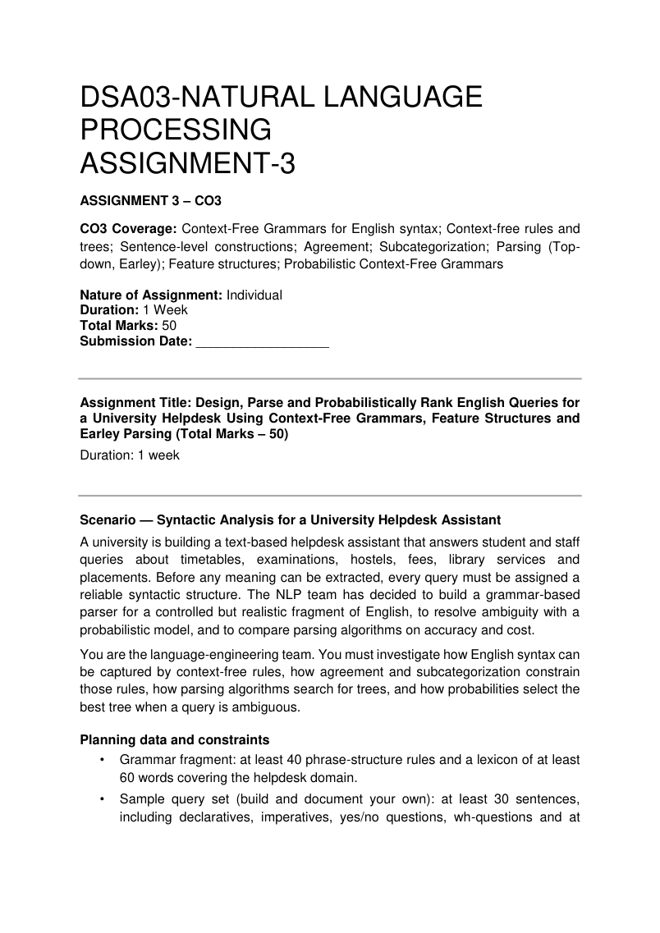
13 - 11 - 2026
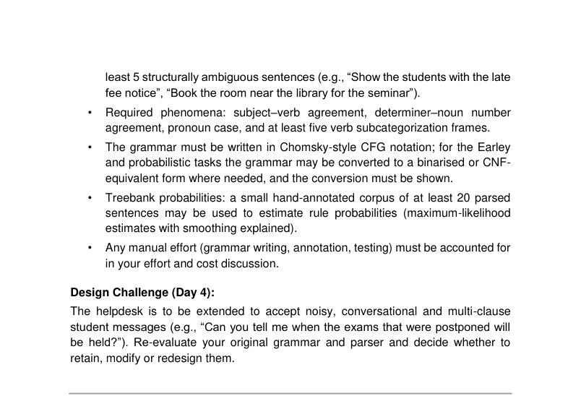

TASK 1 – Design a Context-Free Grammar for English Syntax
Aim: To design a Context-Free Grammar (CFG) for university helpdesk queries.
A CFG is represented as G = (N, Σ, R, S), where N is the set of non-terminals, Σ is the set of terminals, R is the set of production rules and S is the start symbol.
Non-terminal symbols
Symbol | Meaning
S | Sentence
NP | Noun Phrase
VP | Verb Phrase
PP | Prepositional Phrase
Det | Determiner
N | Noun
V | Verb
Adj | Adjective
Adv | Adverb
P | Preposition
WH | Wh-word
Aux | Auxiliary
Conj | Conjunction
AP | Adjective Phrase
RelClause | Relative Clause

Phrase-structure rules
- 1. S → NP VP
- 2. S → Aux NP VP
- 3. S → WH VP
- 4. S → WH Aux NP VP
- 5. S → VP
- 6. S → S Conj S
- 7. NP → Det N
- 8. NP → Det Adj N
- 9. NP → Pron
- 10. NP → ProperN
- 11. NP → NP PP
- 12. NP → NP Conj NP
- 13. NP → Det AP N
- 14. NP → Det N RelClause
- 15. VP → V
- 16. VP → V NP
- 17. VP → V NP NP
- 18. VP → V PP
- 19. VP → V S
- 20. VP → V NP PP
- 21. VP → Aux VP
- 22. VP → Adv VP
- 23. PP → P NP
- 24. AP → Adj
- 25. AP → Adv Adj
- 26. RelClause → RelPron VP
- 27. RelClause → RelPron Aux VP
- 28. WH → What
- 29. WH → When
- 30. WH → Where
- 31. WH → Which
- 32. WH → How
- 33. WH → Why
- 34. Aux → do
- 35. Aux → does
- 36. Aux → is
- 37. Aux → are
- 38. Aux → can
- 39. Aux → will
- 40. Conj → and
- 41. Conj → or
- 42. Conj → but
- 43. RelPron → that
- 44. RelPron → who
- 45. ProperN → library
These are core rules for a teaching grammar. Extend the lexicon and rules as required by the original assessment. A full grammar must be checked against the minimum rule and vocabulary counts specified in the PDF.
Lexicon examples
Category | Words
Nouns | student, students, teacher, timetable, exam, exams, hostel, fee, fees, library, book, room, notice, form, receipt, portal, course, class, placement, result
Verbs | check, submit, send, tell, show, book, apply, pay, need, want, attend, crash, postpone, update, open
Determiners | a, an, the, this, that, these, those, my, your
Adjectives | late, new, old, pending, available, postponed, important, online
Prepositions | in, on, at, for, from, near, with, to, about
Pronouns | I, we, you, he, she, they, me, us, them
Adverbs | today, tomorrow, recently, quickly
Auxiliaries | do, does, is, are, can, will, may
WH words | what, when, where, which, how, why
Conjunctions | and, or, but
Relative pronouns | that, who

Constituency and heads
A constituent is a group of words functioning as one unit. The head is the main word of a phrase. In 'The students submitted the form', 'students' is the head of the subject NP and 'submitted' is the head of the VP.
- Substitution: 'The students' can be replaced by 'They'.
- Movement: 'Near the library' can move to the beginning of a sentence.
- Coordination: 'The timetable and the exam schedule' joins two NPs.
Result: A CFG fragment and a helpdesk lexicon describe basic university-related sentence structures.
TASK 2 – CFG Derivations, Parse Trees and Ambiguity
A derivation is the sequence of grammar rules used to generate a sentence. A parse tree displays the hierarchical structure.
Sentence: The student checks the timetable.
Leftmost derivation
S
⇒ NP VP
⇒ Det N VP
⇒ The N VP
⇒ The student VP
⇒ The student V NP
⇒ The student checks NP
⇒ The student checks Det N
⇒ The student checks the N
⇒ The student checks the timetable
Rightmost derivation
S
⇒ NP VP
⇒ NP V NP
⇒ NP V Det N
⇒ NP V Det timetable
⇒ NP V the timetable
⇒ NP checks the timetable
⇒ Det N checks the timetable
⇒ The N checks the timetable
⇒ The student checks the timetable
Parse tree and bracketed notation
S
/ \
NP VP
/ \ / \
Det N V NP
| | | / \
The student checks Det N
| |
the timetable

(S (NP (Det The) (N student))
(VP (V checks) (NP (Det the) (N timetable))))
Sample sentences
No. | Sentence | Structure
1 | The student checks the timetable. | NP + VP
2 | The teacher submitted the form. | NP + VP
3 | The exam is postponed. | NP + VP
4 | Students need hostel rooms. | NP + VP
5 | The library opens today. | NP + VP

Ambiguity
A sentence is ambiguous if it has more than one valid parse. Example: 'Show the students with the late fee notice.' The PP 'with the late fee notice' may attach to the NP 'the students' or to the VP 'Show the students'. The first reading describes which students; the second describes how or with what the showing is done.
A derivation shows rule application order, while a parse tree shows constituent structure. Different derivation orders may produce the same tree.
Result: CFG derivations and parse trees show how helpdesk sentences are structured and how ambiguity arises.
TASK 3 – Sentence-Level Constructions
Declarative
Declarative sentences provide information. Example: 'The student checks the timetable.' Rule: S → NP VP.
Imperative
Imperatives express commands or requests. Example: 'Submit the form.' The subject 'you' is usually understood. Rules: S → VP; VP → V NP.
Yes/No question
Example: 'Does the student need a hostel room?' Rule: S → Aux NP VP. The auxiliary appears before the subject.
WH-question
Example: 'When will the exams begin?' Rule: S → WH Aux NP VP.
Subordinate and relative clauses
A subordinate clause depends on another clause: 'Tell me that the fee is paid.' A relative clause describes a noun: 'The exams that were postponed will begin tomorrow.'
Coordination and long-distance dependencies
Coordination joins phrases or clauses using and, or or but. Example: 'The student paid the hostel fee and library fee.' In 'Which exam did the teacher postpone?', the fronted phrase 'Which exam' is related to the object position after 'postpone'.
Result: Declarative, imperative, yes/no and WH constructions can be represented using CFG rules, with additional rules for subordinate clauses and coordination.
TASK 4 – Agreement
Agreement means that grammatical features of related words must match.
- Subject–verb agreement: 'The student submits'; 'The students submit'.
- Determiner–noun agreement: 'This book'; 'These books'.
- Pronoun case: 'She submitted the form'; 'The teacher helped her'.
Agreement rules
S → NP-SG VP-SG
S → NP-PL VP-PL
NP-SG → Det-SG N-SG
NP-PL → Det-PL N-PL
VP-SG → V-SG NP
VP-PL → V-PL NP
Rule explosion
If a grammar separately represents person (3 values), number (2), gender (3) and case (3), it may need to consider 3 × 2 × 3 × 3 = 54 feature combinations. Separate rules for every combination make the grammar large.
Feature-based alternative
S → NP VP NP.NUM = VP.NUM
NP → Det N Det.NUM = N.NUM
Sentence | Agreement-aware result
The student submits the form. | Accept
The students submit the form. | Accept
The students submits the form. | Reject
These book is new. | Reject
Her submitted the form. | Reject
The student submit the form. | Reject

A basic CFG without agreement constraints may accept incorrect combinations. Feature-based constraints reject them.
Result: Agreement features improve grammatical correctness and reduce the need for many separate rules.
TASK 5 – Subcategorization
Subcategorization specifies the complements selected by a verb, also called verb valence.
Frame | Structure | Example
Intransitive | V | The portal crashed.
Transitive | V + NP | Submit the form.
Ditransitive | V + NP + NP | Send me the receipt.
Sentential complement | V + S | Tell me that the fee is paid.
PP complement | V + PP | Apply for a hostel room.

Grammar rules
VP → V-INTR
VP → V-TRANS NP
VP → V-DITRANS NP NP
VP → V-COMP S
VP → V-PP PP
A complement is required or selected by a verb. An adjunct gives optional information such as time, place or manner. In 'Submit the form today', 'the form' is the object complement and 'today' is an adjunct.
Verbs may have more than one frame depending on meaning and context. Incorrect or missing complements can cause a sentence to be rejected by a grammar.
Result: Subcategorization helps identify the complements required by different verbs.
TASK 6 – Top-Down Parsing
Top-down parsing starts from the start symbol S and expands grammar rules until the input sentence is generated.
Algorithm
- Start with S on the stack.
- If the top symbol is a non-terminal, expand it using a grammar rule.
- If it is a terminal, compare it with the next input word.
- If it matches, consume the word.
- If it does not match, backtrack and try another rule.
- Accept when all words are consumed and the stack is empty.
Pseudocode
def parse(symbols, words):
if not symbols:
return len(words) == 0
first = symbols[0]
if first in grammar:
for rule in grammar[first]:
if parse(rule + symbols[1:], words):
return True
return False
if words and first == words[0]:
return parse(symbols[1:], words[1:])
return False
For 'The student checks the timetable', the parser expands S → NP VP, NP → Det N, matches 'The student', expands VP → V NP and matches 'checks the timetable'. The sentence is accepted.
A left-recursive rule such as NP → NP PP may cause infinite recursion in a simple recursive-descent parser. It can be rewritten as NP → N NP' and NP' → PP NP' | ε.
Result: Top-down parsing is simple, but left recursion and repeated backtracking can reduce efficiency.
TASK 7 – Earley Parsing
Earley parsing is a dynamic-programming algorithm that stores partial parsing results in chart positions. A state is written [A → α • β, i], where i is the origin position.
Three operations
- Predictor: Adds grammar rules for the next expected non-terminal.
- Scanner: Matches the next expected terminal with the input word.
- Completer: Completes a constituent and advances earlier states waiting for it.
Example
Sentence: 'The student checks the exam timetable.' Tokens: The / student / checks / the / exam / timetable.
S → NP VP
NP → Det N
NP → Det N N
VP → V NP
Det → 'the' | 'The'
N → 'student' | 'exam' | 'timetable'
V → 'checks'
Chart position | Main action
0 | Predict S → • NP VP; predict NP → • Det N
0–1 | Scan 'The' as Det
1–2 | Scan 'student' as N; complete NP
2 | Predict VP → • V NP
2–3 | Scan 'checks' as V
3 | Predict NP alternatives
3–4 | Scan 'the' as Det
4–5 | Scan 'exam' as N
5–6 | Scan 'timetable' as N; complete NP
6 | Complete VP and S; accept

The completed state at the final chart position shows that the sentence is recognized. Back-pointers can be used to recover the parse tree. Multiple back-pointers preserve alternative parses.
For a general CFG, standard worst-case complexity is O(n³) time and O(n²) space, where n is sentence length. Earley parsing handles left recursion by checking and reusing chart states.
Result: Earley parsing reduces repeated work and supports ambiguous and left-recursive grammars.
TASK 8 – Feature Structures and Unification
A feature structure stores grammatical attributes and values, such as category, number, person and case.
[ CAT: NP
NUM: singular
PER: third
CASE: nominative ]
Word | Category | Features
student | N | NUM=singular
students | N | NUM=plural
submits | V | NUM=singular, PER=third
submit | V | NUM=plural
she | Pronoun | NUM=singular, PER=third, CASE=nominative
her | Pronoun | NUM=singular, PER=third, CASE=accusative

Unification
Unification combines compatible feature structures. [NUM: singular] and [PER: third] unify as [NUM: singular, PER: third]. But [NUM: singular] and [NUM: plural] cannot unify because the values conflict.
Subsumption
A feature structure A subsumes B when A contains less specific information and all its features are compatible with B. [NUM: singular] subsumes [NUM: singular, PER: third].
Feature-based rules
S → NP VP NP.NUM = VP.NUM
NP → Det N Det.NUM = N.NUM
VP → V NP V.SUBCAT = transitive
VP → V V.SUBCAT = intransitive
In 'The student submits the form', the subject NP and verb both have singular number and third person. Their features match, so the sentence passes the agreement check.
Result: Feature structures and unification represent agreement and subcategorization without creating many separate CFG rules.
TASK 9 – Probabilistic Context-Free Grammars
A PCFG assigns a probability to every production rule. For each left-hand-side non-terminal, the probabilities of its alternative rules must sum to 1.
Maximum-likelihood estimate: P(A → β | A) = Count(A → β) / Total count of rules beginning with A.
Rule | Illustrative count | Probability
S → NP VP | 16/20 | 0.80
S → Aux NP VP | 4/20 | 0.20
NP → Det N | 12/20 | 0.60
NP → Pron | 5/20 | 0.25
NP → ProperN | 3/20 | 0.15
VP → V NP | 10/20 | 0.50
VP → V | 6/20 | 0.30
VP → V PP | 4/20 | 0.20

The counts above are illustrative. Probabilities for each left-hand-side category sum to 1.
Parse-tree probability
The probability of a parse tree is the product of the probabilities of all rules used in that tree.
Example: 0.80 × 0.60 × 0.50 × 0.60 = 0.144.
Ambiguous parse ranking
For 'Show the students with the notice', suppose the NP-attachment tree has probability 0.018 and the VP-attachment tree has probability 0.015. The NP-attachment tree is selected because it has the higher probability. These are sample values only.
The sentence probability is the sum of probabilities of all its possible parse trees: 0.018 + 0.015 = 0.033.
Viterbi CKY
- Convert the grammar to Chomsky Normal Form (CNF).
- Initialize chart cells using lexical rules.
- For each span, try every split point.
- Apply binary rules and multiply rule and child probabilities.
- Store the highest probability and back-pointer.
- Return the best parse from the full-span cell under S.
CNF rules have forms A → B C or A → word. A rule such as VP → V NP PP can be binarized as VP → V X and X → NP PP.
Limitations: basic PCFGs make independence assumptions, are not fully context-sensitive, may not capture lexical preferences and can select a likely structural parse that is semantically unsuitable.
Result: PCFGs rank alternative parse trees and select the most probable syntactic structure.
TASK 10 – Implement and Test the Parsers
Aim: Implement top-down parsing, Earley parsing and probabilistic parsing in Python. Install NLTK and Matplotlib if required.
pip install nltk matplotlib
Python demonstration
import nltk, time
import matplotlib.pyplot as plt
from nltk import CFG, PCFG
from nltk.parse import RecursiveDescentParser, EarleyChartParser, ViterbiParser

grammar = CFG.fromstring(\'''
S -> NP VP
S -> Aux NP VP
S -> VP
NP -> Det N
NP -> Pron
NP -> NP PP
VP -> V
VP -> V NP
VP -> V PP
VP -> V NP PP
PP -> P NP
Det -> 'the' | 'a'
N -> 'student' | 'students' | 'form' | 'timetable' | 'exam' | 'library' | 'room' | 'notice'
V -> 'checks' | 'check' | 'submit' | 'submits' | 'crashed' | 'book' | 'show'
Pron -> 'she' | 'they'
Aux -> 'does' | 'can'
P -> 'with' | 'near' | 'for'
\''')

sentences = [
"The student checks the timetable",
"The students check the timetable",
"The student submits the form",
"She checks the exam",
"They book the room",
"The student checks the exam timetable",
"The student checks the form",
"The students submit the form",
"The student checks the notice",
"The student books the room",
"The student checks the timetable with the notice",
"The student books the room near the library",
"Show the students with the notice",
"Book the room near the library",
"The portal crashed"
]

top = RecursiveDescentParser(grammar)
earley = EarleyChartParser(grammar)

for sentence in sentences:
words = sentence.lower().split()
for name, parser in [("Top-down", top), ("Earley", earley)]:
start = time.perf_counter()
try:
count = len(list(parser.parse(words)))
except Exception:
count = 0
elapsed = time.perf_counter() - start
print(sentence, name, "parses:", count,
"time:", round(elapsed, 6))

chart = earley.chart_parse(words)
print("Earley chart states:", len(chart))

pcfg = PCFG.fromstring(\'''
S -> NP VP [1.0]
NP -> Det N [0.7] | Pron [0.3]
VP -> V NP [0.7] | V [0.3]
Det -> 'the' [0.7] | 'a' [0.3]
N -> 'student' [0.4] | 'form' [0.3] | 'timetable' [0.3]
V -> 'checks' [0.5] | 'submits' [0.5]
Pron -> 'she' [1.0]
\''')

parser = ViterbiParser(pcfg)
print(list(parser.parse("the student checks the form".split())))
This is a small demonstration grammar. Extend it to cover the full assessment test set. Record actual parse counts, chart states and runtime from execution. Do not report unexecuted values as experimental results.
Model | Measure to record
Top-down parser | Accepted parses, runtime
Earley parser | Accepted parses, chart states, runtime
PCFG/Viterbi | Best parse, probability, runtime

Result: The code demonstrates how to run parsers and obtain measurements for comparison.
TASK 11 – Compare, Recommend and Defend the Design
Method | Strength | Limitation
Top-down | Simple and easy to understand | Backtracking and left recursion can cause problems
Earley | Handles left recursion and ambiguity using chart states | May use more memory for long sentences
PCFG/Viterbi | Ranks parses and selects the highest-probability tree | Requires annotated training data and estimated probabilities

Recommended design: Feature-based CFG + Earley parser + PCFG ranking. Feature structures check agreement and subcategorization. Earley parsing handles ambiguity and recursion. PCFG ranking chooses the most probable parse among alternatives.
The final recommendation must be validated using a labelled test set. Measure parse accuracy, coverage, runtime and memory. Unseen words, informal language and incorrect probability estimates remain limitations.
Result: The combined design balances grammatical constraints, ambiguity handling and probabilistic ranking.
TASK 12 – Day-4 Design Challenge: Re-evaluate and Adapt the Design
A. Impact Analysis
The expanded helpdesk receives conversational, multi-clause and partly ungrammatical messages. Examples include: 'Can you tell me when the exams that were postponed will be held?', 'I paid the fee but the portal still shows pending', and 'Exam postponed, when new date?'
- New constructions include embedded questions, relative clauses and coordinated clauses.
- Messages may contain missing punctuation, fragments and informal wording.
- The original controlled grammar may reject constructions that are not covered by its rules.
- Longer sentences may increase ambiguity and the number of possible parses.
B. Evaluation of Original Design
Message | Possible original-system issue
Can you tell me when the exams will begin? | Embedded WH-clause may not be covered
I paid the fee but the portal shows pending. | Coordination of clauses may be missing
Exam postponed, when new date? | Fragment and omitted grammatical words

Top-down parsing may backtrack repeatedly. Earley parsing handles ambiguity more effectively, but cannot recognize structures absent from the grammar. Partial parsing can still identify useful phrases when a complete parse fails.
C. Adaptation or Redesign
Decision: Modify the original design rather than replace it completely.
- Extend CFG rules for embedded questions, relative clauses, coordination and multi-clause sentences.
- Use feature structures for agreement, case and verb subcategorization.
- Use Earley parsing for ambiguous and recursive structures.
- Use PCFG ranking to select among alternative parse trees.
- Add partial parsing to identify useful phrases when complete parsing fails.
- Add unknown-word handling and error recovery for incomplete messages.
Revised grammar examples
S → NP VP
S → S Conj S
S → Aux NP VP
S → WH Aux NP VP
VP → V NP
VP → V S
VP → V WH S
NP → Det N RelClause
RelClause → RelPron VP
VP → VP PP
Revised architecture
Student Message
|
Text Preprocessing
|
Tokenization
|
Extended Feature-Based CFG
|
Earley Parser
|
Feature Checking
|
PCFG Parse Ranking
|
Partial Parsing if Needed
|
Helpdesk Query Structure
Factor | Original design | Modified design
Grammar coverage | Limited | Wider
Agreement | Basic | Feature-based
Ambiguity | Multiple parses | Ranked parses
Long sentences | Limited support | Improved support
Unknown constructions | Rejected | Partial parsing
Maintenance | Manual rules | Rules plus training data

D. Evidence-Based Defence
The modified system is suitable because it accepts more realistic student messages. Earley parsing handles ambiguous and recursive structures, feature structures improve agreement, PCFG ranking selects likely parses, and partial parsing prevents rejection of every message containing an unknown construction.
The assessment's expected proportion of unseen constructions should be tested on a representative sample. Do not claim a specific improvement unless it is measured. Remaining limitations include spelling errors, code-mixing, informal language and complex semantic relationships.
Result: Extending the grammar and combining feature structures, Earley parsing, PCFG ranking and partial parsing provides a more robust helpdesk parser.
OVERALL CONCLUSION
This assignment explains how Context-Free Grammars represent English sentence structures and how parse trees show grammatical relationships. Agreement and subcategorization improve grammar accuracy, while feature structures reduce rule multiplication. Top-down and Earley parsing generate syntactic structures, and PCFGs rank ambiguous parses. The revised helpdesk design combines feature-based grammar, Earley parsing, probabilistic ranking and partial parsing to handle more realistic student messages.
FINAL CHECK BEFORE SUBMISSION
- Verify that the grammar has at least the minimum number of phrase-structure rules required by the PDF.
- Verify that the lexicon meets the PDF's minimum vocabulary size.
- Add all derivations, parse trees and ambiguous examples explicitly required by the assessment.
- Use the required number of annotated sentences for PCFG estimation.
- Run the Python programs and replace illustrative values with actual output.
- Check the exact marks and sub-question wording against the original PDF.

